

**THE**

**FORE RUNNERS**

Believe everything is possible

**Degree:** BSc (Honours) Software Engineering

**Stage:** 3

**Batch:** 14.2

**Supervisor:** Mr. Udesh Amarasinghe

**INDEX NUMBER FULL NAME**

10541973 Basura Ratnayake

Gruha Pathi 1.0 - A new frontier in HOME Automation

Interim Report One

Table of Contents

Tasks Undertaken and Outcomes 1

Products Produced and Product Quality 2

Risks that have Materialized and Solutions 3

Schedule 3

Resources 4

Learning Undertaken 4

References 5

# Tasks Undertaken and Outcomes

1. **Acquisition of Electronic Components**

As planned, on October began to purchase the electronic components such as capacitors, resistors, transistors, ICs and Sensors that are required for the completion of the project. Managed to purchase all required electronics for the project by November ahead of schedule.

1. **Development of Hardware Components**

As planned began work on the core hardware components on November and managed to build and test prototypes of the core hardware components ahead of schedule.

* **Transformer Circuit,** is used to transform mains voltage (230V AC) to variable outputs 5V and 12V DC.
* **Communication Circuit**, is used to transmit and receive data and commands between devices. 433 MHz frequency based transmitter and receiver is used to accomplish this task.
* **Relay Circuit,** controls the switch ON/OFF state of 230V device.
* **Voltage Measurement Circuit,** measure the amount of WATT/h used by the external device.
* **Motion Circuit,** uses a PIR sensor which detects movement and activates the relay circuit.
* **Processor Circuit,** controls and manages all the sub components (Communication, Relay and Motion circuits) of the device. This is accomplished by an ATMEGA328-PU IC;
* **Switch Device,** comprises of the above mentioned four circuits. The purpose of this component is to provide the user with the ability to wireless switch ON/OFF a device and obtain the power consumption of the device to which it is connected.
* **Power Socket Device,** is designed similar to the switch component the only difference being the device attached to the power socket can be changed at will.

1. **Development of GUI Designs**

As planned began work on the GUI designs on November and managed to design only two GUIs as of now. Running behind schedule on development of GUI Design.

* **Splash Screen,** when the application is executed before it fully loads, checks for all software components, internet connection, and device validation.
* **Login Screen,** asks the user to input login credentials in order to gain access to the system.

# Products Produced and Product Quality

1. **Switch Device and Power Socket Device.**

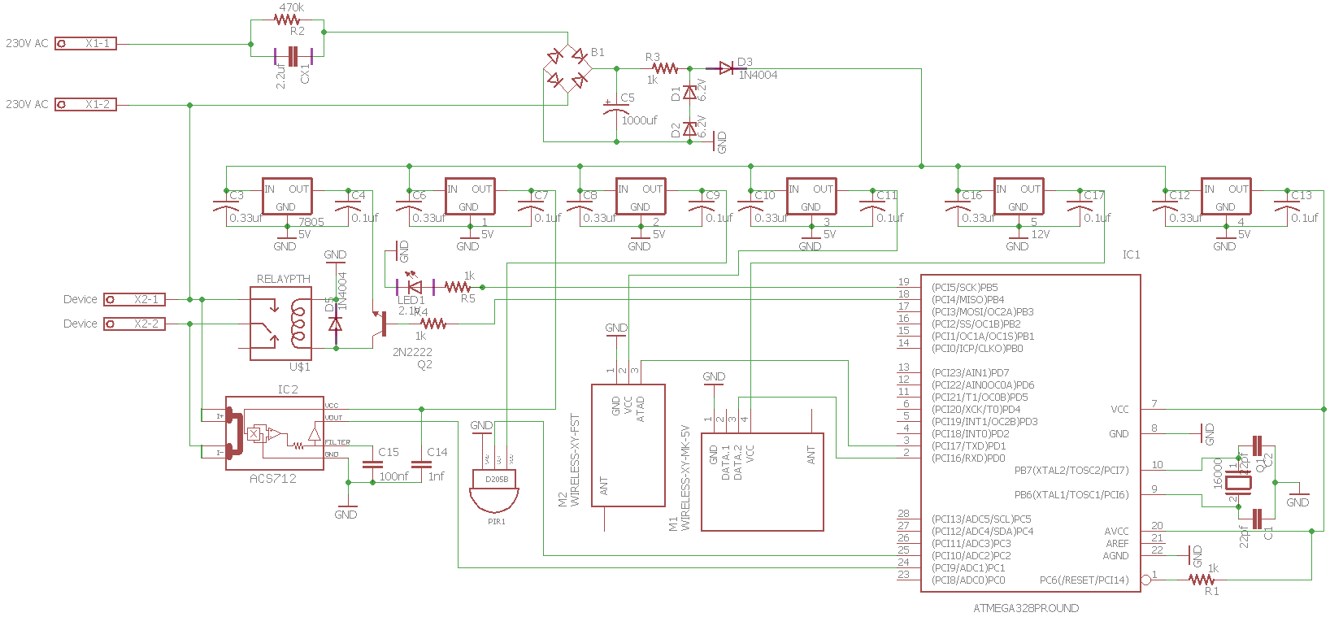Managed to reduce the size of the device by removing transformer and introducing a diode based rectification. This device can fit into a normal switch or power socket at any home.

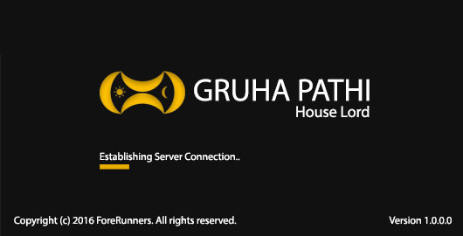

1. **Splash Screen**

Scan the system on application start up, check for the availability of the internet connection and validate the device before launching the Log in interface.

1. 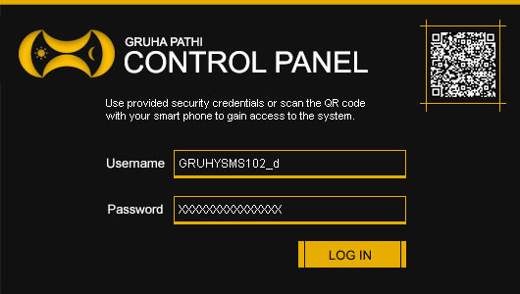**Login Screen**

A user can log into the system using username and password combo or else by the using their smartphone to scan to QR Code to gain access.

# Risks that have Materialized and Solutions

1. **Voltage Transformation**

Transforming 230V AC (Mains) to 5V and12V DC (Variable Outputs) with 1 amp posed a great challenge. To transform Mains to Variable output required an electrical transformer which was large in size, I fixed this issue by using capacitor based transformation and use voltage regulator ICs to obtain 12V, 5V DC respectively.

1. **Wireless** **Communication**

RF 433MHZ wireless communication (RF Modules) is used to receive and transmit data and commands to and from devices. The issue faced here was the initial range of RF module transmission distance which was 12cm, after much research managed to solve it by using a signal booster and a 17cm long antenna.

1. **Size of Components**

With the circuit prototype testing it became evident that size of the devices has increased by 20% in comparison to the initial planned component size. The solution for this issue would be to use SME (Surface Mounted Electronic) but I have no experience with them as of now, I plan to gain knowledge on the subject.

1. **Size of Memory**

The storage capacity of ATMEGA328-PU is 32KB which is not enough to store all the planned functionality of the device therefore in order to solve the issue I used ROM IC 24c64 which contains a capacity of 32 KB the resulting storage capacity is 64KB (ATMEGA328-PU + 24c64).

# Schedule

**On Schedule Little Off Schedule Failed to Complete Not Started**

|  |  |  |  |  |  |  |  |  |  |  |  |  |
| --- | --- | --- | --- | --- | --- | --- | --- | --- | --- | --- | --- | --- |
| Stage | October | November | | December | | January | | February | | March | | April |
| **One** |  |  |  | |  | |  | |  | |  | |
| **Two** |  |  |  | |  | |  | |  | |  | |
| **Three** |  |  |  | |  | |  | |  | |  | |
| **Four** |  |  |  | |  | |  | |  | |  | |
| **Five** |  |  |  | |  | |  | |  | |  | |

# Resources

Project capital is Rs. 10,000. As of now 40% of the capital was spent purchasing electrical and electronic components. The following items were purchased,

**Hardware**

* Electrolytic and Ceramic Capacitors (1nf – 1000uf)
* Resistors (100ohms – 1mega ohm)
* Transistors (PN2222A, TIP120, BD140)
* Integrated Circuits (ATMEGA328-PU, LM7805, LM7812, ACS712, 24C64, NE555)
* Sensors (PIR, IR)
* Others (Servo, Motor Shield, Water Flow Detector, Arduino Uno, LAN Shield, WIFI Shield, 433mhz Transmitter, 433mhz Receiver, etc.)

**Software**

* CADSOFT Eagle

# Learning Undertaken

* **Research on Home Automation Systems**

Presently in Sri Lanka, there are no home automation systems only collections home automation gadgets and lacks a complete functional system. There are only two major home automation gadget providers in Sri Lanka

1. **Dialog Smart Home,** lacks a complete functional system and use independent gadgets from Movinta.
2. **HomeTec Lanka,** has no functional system but independent gadgets that work over Wi-Fi.

* **Micro-Controller Programming**

Learned Arduino based programming and to operate sensors connected to Arduino

* **Electrical and Electronic Theories**

Learned the basics of electronics in order to create schematics and circuits from schematics.

* **Smartphone Application Development**

Gained the basic knowledge to create a smartphone application using Android Studio, Phone Gap and Ionic Framework.

# References

1. Dialog and Movinta Pioneer Smart Home Technology. Dialog. Available at: <https://www.dialog.lk/smarthome>
2. Your Trusted Partner in Security & Home Automation Since 2008. HomeTec Lanka. Available at: <http://www.hometeclanka.com/index.html>
3. YouTube Channel. Electronics. Available at: <https://www.youtube.com/user/makemagazine/playlists>
4. YouTube Channel. Android Development. Available at: <https://www.youtube.com/playlist?list=PLAgylfU8wrtvWlSlVhFQZtE311sProxQF>
5. YouTube Channel. Android Development. Available at: https://www.youtube.com/playlist?list=PLAgylfU8wrtvWlSlVhFQZtE311sProxQF